

Request for Quotation
ETBI Building Redesign Project

Education and Training Boards Ireland (ETBI)
Pipers Hill Campus
Kilcullen Road
Naas
Co. Kildare
W91K723

SECTION 1 KEY INFORMATION

1.1 Context
This Request for Quote (RFQ) is an invitation to experienced architectural firms to submit quotations for the preparation of detailed architectural plans and phasing strategy for the update of the existing ETBI building and separately the procurement of and oversight of construction stage services.

1.2 Our timelines
Here is our anticipated timeline for this RFQ.

Deadline for Quotes: | 13 November 2023
Anticipated Contract start date: | 30 November 2023
Anticipated Contract finish date: | 29 January 2024

All dates and times stated are local time.

1.3 How to contact us.
- All enquiries must be directed to ETBI’s nominated Point of Contact. We will manage all external communications through this Point of Contact only.
- Our Point of Contact
Name: Melanie Dunne
Email address: melanie.dunne@etbi.ie

1.4 Developing and submitting your Quote.
- You must use the Response Form provided further below.
- You may only include product brochures and appendices that are relevant to your response.

1.5 Manner for submitting your Quote.
- Quotes must only be submitted by email/electronically to the following address:
melanie.dunne@etbi.ie
- Quotes sent by post or fax, or hard copy delivered to ETBI, will not be accepted.

1.6 Our RFQ Process, Terms and Conditions
- Offer Validity Period: In submitting a quote the supplier/service provider agrees that their quote will remain open for acceptance by ETBI for three (3) calendar months from the Deadline for Quotes.
- This RFQ is subject to our standard terms and conditions a copy of which is available upon request.
SECTION 2 OUR REQUIREMENTS

2.1 Objective/Scope of Work of the Project

Development of plans to repurpose and transform the ETBI office building, formerly utilised as traditional offices and open plan workspaces into functional meeting, collaboration, and training spaces.

The appointed architectural firm will be responsible for the following:

- Conducting an initial consultation with ETBI representatives to fully understand the project brief.
- Conducting site visits and assessments as required.
- Preparing detailed architectural plans that will facilitate:
  - Comprehensive renovation and update of the ETBI building.
  - Phasing out of the construction work, ensuring minimum disruption to the daily activities of the building during the renovation period.
- Ensuring that all plans comply with local building regulations and any other relevant standards.
- Providing digital and printed copies of the plans.

2.2 Background

Education and Training Boards Ireland (ETBI) is the national representative body established to collectively represent the 16 Education and Training Boards (ETBs) across Ireland and promote their interests, which is recognised by the Minister for the purposes of the Education and Training Boards Act 2013. ETBI comprises of the staff of ETBI, the ETBI Chief Executives, Directors of Further Education and Training, Directors of Schools, Directors of Organisation, Support and Development Forums and the respective networks and groups associated with these forums.

In the months prior to the Covid 19 Pandemic, ETBI were considering plans to further develop the building to accommodate a significant increase in the number of employees, growing from 16 in 2013 when the building opened, to 30 in 2019. Due to the success of the remote working model that was implemented during Covid, coupled with a further increase in employee numbers, now 62, the decision has been made for ETBI to remain a ‘Remote First’ organisation with most employees primarily working remotely.

2.3 The building

ETBI is a 2-story building, built circa 2010, comprising of the ground floor with large entrance foyer, 1 small meeting room, 2 offices, storage area, kitchen, cafeteria, archive file and comms rooms, 74 seat lecture theatre and toilet facilities. The 1st floor comprises of a large boardroom, a meeting room with moveable folding partition, 12 own door offices of varying sizes, small kitchenette, break out area, large open plan workspace area and toilet facilities.

2.4 The Vision

To create an inviting, contemporary environment to aid innovation, improve collaboration and increase productivity for ETBI hybrid working employees and wider stakeholders across the sector. An environment that seamlessly combines the benefits of physical presence and remote collaboration, transcending traditional office setups.

The vision to achieving this:

- Nature Inspired Workspace
Envision a workspace designed with inspiration from nature, featuring biophilic design elements like natural lighting, indoor plants, and calming colours to promote well-being and creativity for in-person attendees.

- Digital Nerve Centre
A central hub equipped with state-of-the-art technology, serving as the core of the hybrid setup, connecting remote participants from across the sector with those present in the physical workspace.

- Adaptability Oasis
Visualise flexible furniture arrangements that can adapt to various meeting styles and sizes. Tables and chairs with built-in power and data connections seamlessly transition between individual workstations and collaborative hubs.

- Collaboration Spaces
Envision interactive collaboration spaces equipped with touchscreens and spatial audio. These spaces are designed for brainstorming and ideation sessions where both in-person and remote teams can contribute effortlessly.

- Serene Focus Zones
Create quiet alcoves where individuals can retreat for concentrated work. Spaces designed for staff who need privacy while attending the ETBI building, ensuring productivity without distraction.

- State of the Art Boardroom(s)
Cutting-edge boardroom(s) with state-of-the-art technology. These spaces allow for immersive presentations and simulations, making remote presentations feel as engaging as in-person ones.

- A Sustainable Sanctuary
Envision sustainable materials and energy-efficient technologies that reduce the environmental footprint of the hybrid space. Solar panels, rainwater harvesting, and recycling stations to promote eco-conscious practices.

- A Hybrid Culture Corner
A corner where organisation culture shines, featuring success stories, employee recognition and interactive displays, keeping everyone, regardless of location, connected to the organisations’ values.

- Continuous Evolution Path
A commitment to constant innovation, where the hybrid space adapts and evolves alongside emerging technologies and changing work dynamics.

In this visionary approach, the hybrid workspace is a harmonious blend of technology, nature, adaptability, and inclusivity. It doesn't just facilitate work, it elevates the way teams collaborate, foster well-being, and embrace the future of work.

2.5 Goals of the ETBI Building Redesign Project

To create and provide multiple meeting, collaboration and training spaces of various sizes that are multi-functional, adaptable, and reconfigurable that integrate technology to cater for both in-person and remote participants, while also considering aspects like flexible seating arrangements, lighting, acoustics, ergonomic furniture and general interior furnishings and design refresh.

- Small Meeting Rooms
For team meetings and smaller gatherings, equipped with video conferencing technology.

- Full Hybrid Meeting Rooms
For Board, forum meetings and larger team meetings, these rooms will feature video conferencing technology and modular furniture to allow for flexible seating arrangements.

- Multipurpose Event Space
For larger group meetings, reconfigurable between cabaret and theatre style with AV appropriate for the room size, intended to be optimised for in-person participation.

- Flexible and Fixed Workspaces
To cater to staff who work in the building and for staff who require workspaces before and after meetings.

2.6 The Current and Proposed Spaces

2.6.1 Ground Floor
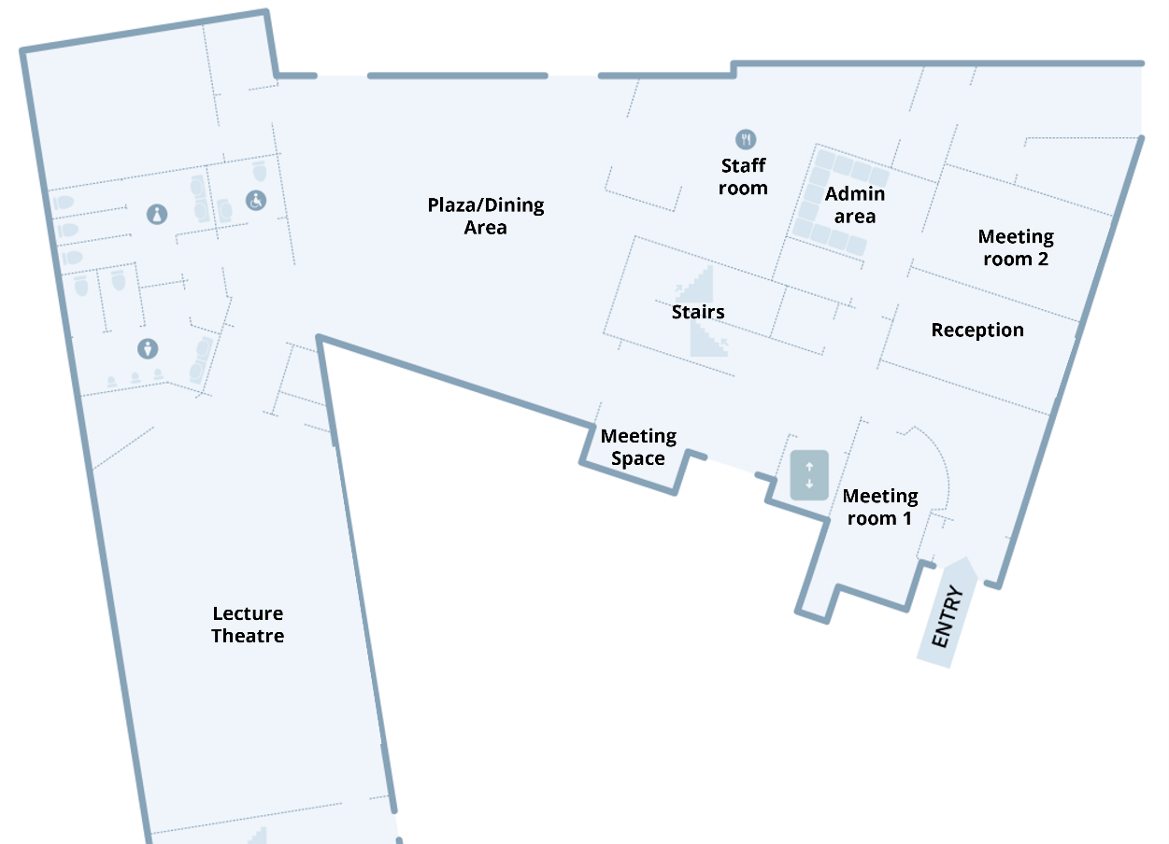

- Reception to Boardroom
On entering the building, the current reception office is located inside the entrance foyer, with a traditional style sliding glass hatch for welcoming visitors. The current Reception is located back-to-back with another office( Meeting room 2) of the same size, divided by dry wall. It is proposed to remove the dry wall partition and create a hybrid boardroom type space to seat eighteen attendees that is accessible from the foyer, replacing the current glass sliding hatch with appropriate door access.

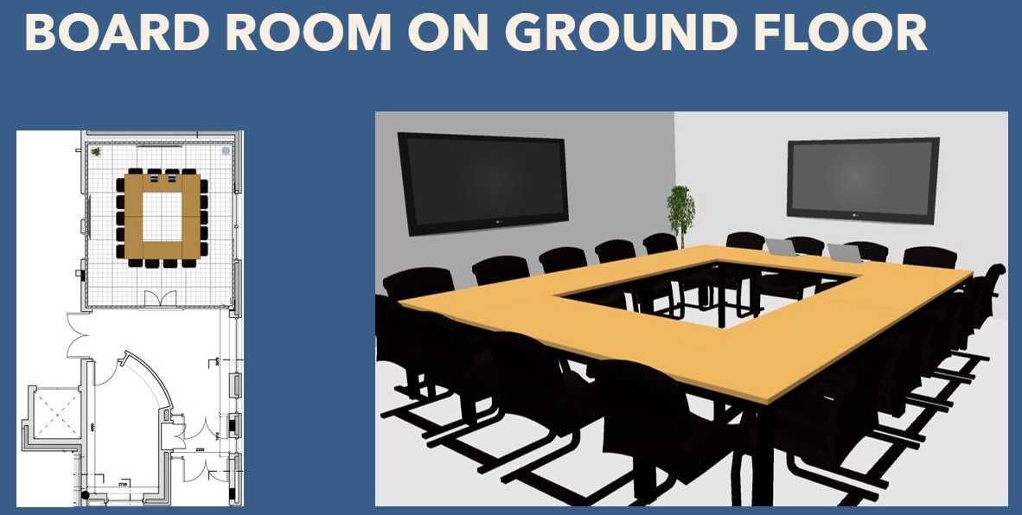

- Small Meeting Room to Facility Administrator Office
Also accessible from the foyer opposite the reception office is a small meeting room. It is envisaged that this meeting room be reconfigured into a new reception or facility administration office.

- Storage/Stationary Area
This area may be redesigned, with no access directly to the staff room or exit.

- Kitchen/Staff Room/Servery
Upgrade and refresh kitchen cabinetry and seating area furniture used by onsite staff. Redesign of servery hatch to incorporate wider, longer serving area.

- The Plaza (cafeteria)
Replacement of cafeteria furniture to include more contemporary flexible furniture that can be easily moved and reconfigured for different gathering formats when required.

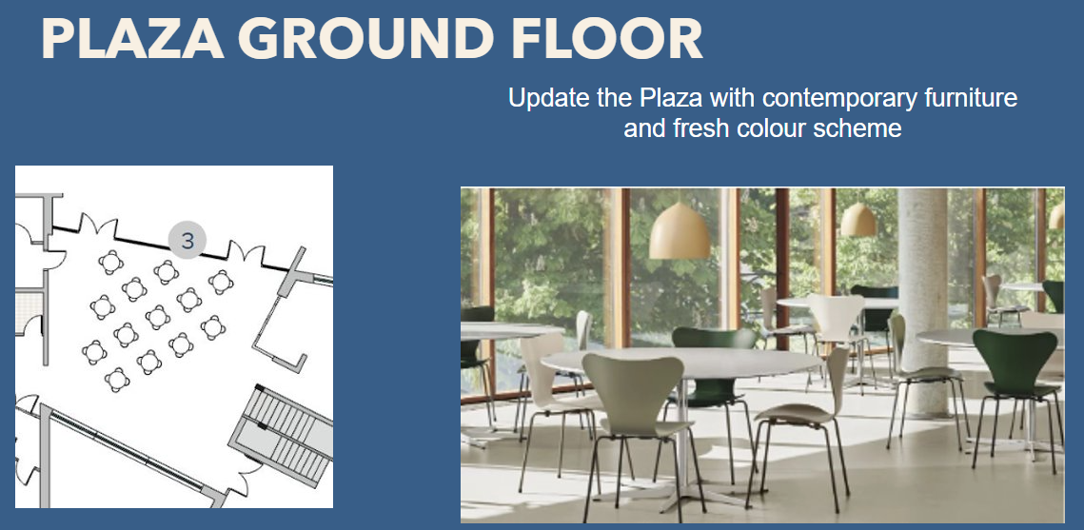

- Archive File Room
Review the purpose of this space, can this space be re-imagined to other purpose such as a media room or recording studio. Removal of equipment that is no longer used.

- Toilet Facilities
Upgrade and refresh of accessible, female and male bathroom facilities.

- Lecture Theatre
A resolution is sought to rectify the pertinent issue with accessibility. Currently, the lecture theatre is not accessible, insofar as, if the presenter has reduced mobility there is no access down to the presentation area from inside the building. Access to the lecture theatre is from the Plaza cafeteria, a series of steps and tiered seating exist that one must be able to navigate in order to gain access to the presentation lectern. The only other access point is the fire exit that leads from the presentation area to the exterior of the building. Upgrade and refresh of seat covering to be considered also.

- Glass Waiting Area/Lobby to Meeting Space/Pod
Create small meeting space incorporating existing glass alcove space with sit to stand desk and appropriate ergonomic seating for private video calls and meetings.

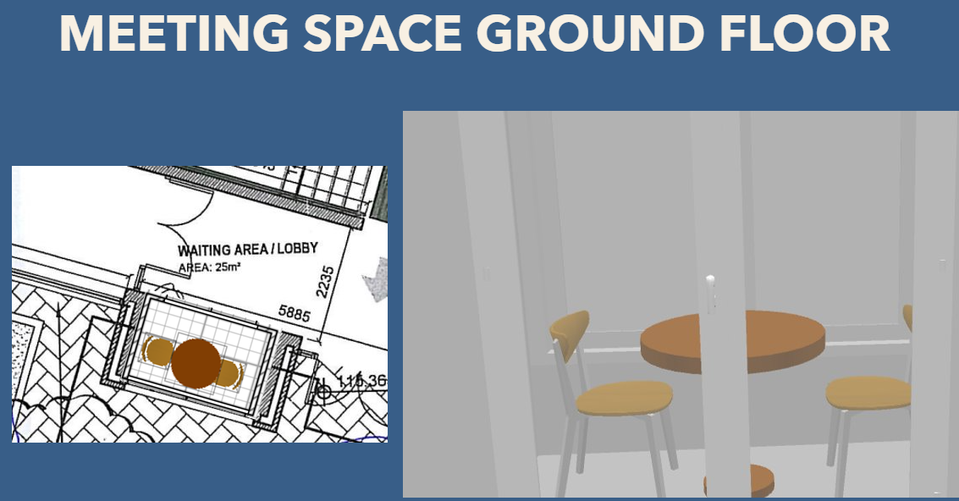

2.6.2 First Floor

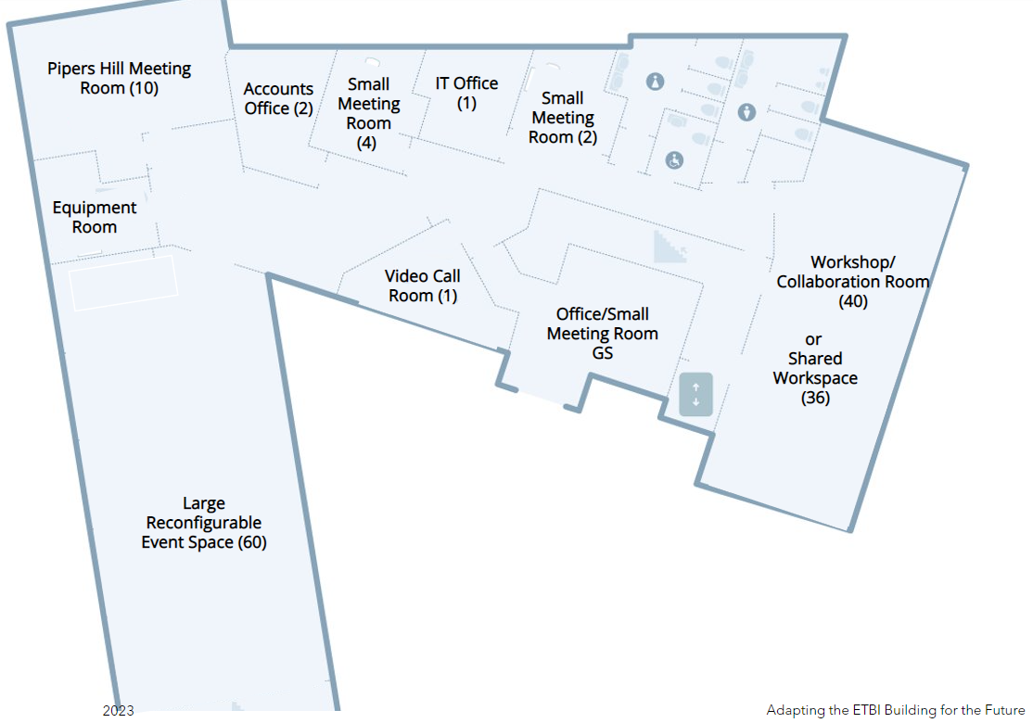

- Boardroom to Boardroom/Collaboration Room
Consider redesign into multi-functional hybrid training and collaboration space incorporating adaptable sit to stand desking and ergonomic seating that is easily moved and reconfigurable to accommodate max. 45 attendees.

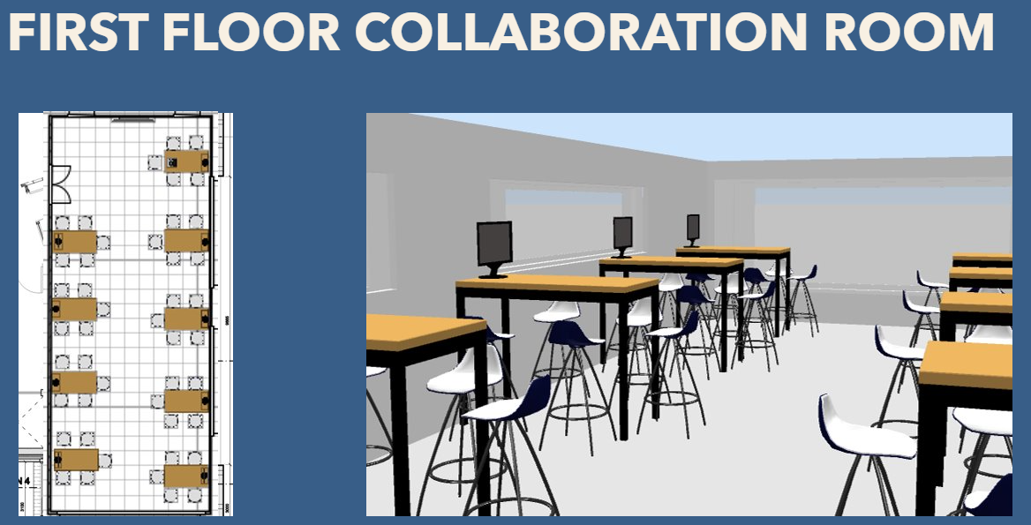

- Pipers Hill Room
Originally this room was designed as 1 medium sized meeting room that could be turned into 2 small meeting rooms using a moveable partition wall system. It is proposed to remove the moveable partition wall completely and redesign into a medium sized hybrid meeting space with furniture to accommodate approximately 15/20 attendees.

- Open Plan Area with 5 adjacent offices to Large Event Space
It is proposed to deconstruct the 5 adjacent offices and open all office space into 1 large multi-functional hybrid space with reconfigurable furniture and seating primarily used for conferencing and training, incorporating a projection/screen wall with storage space behind for furniture not in use.

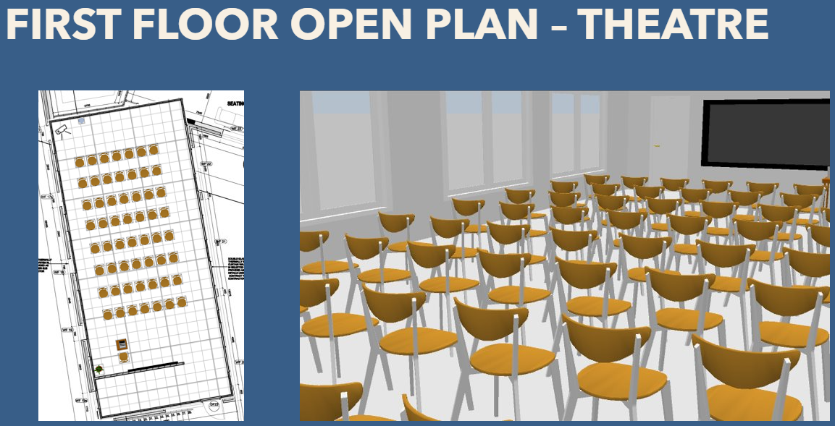

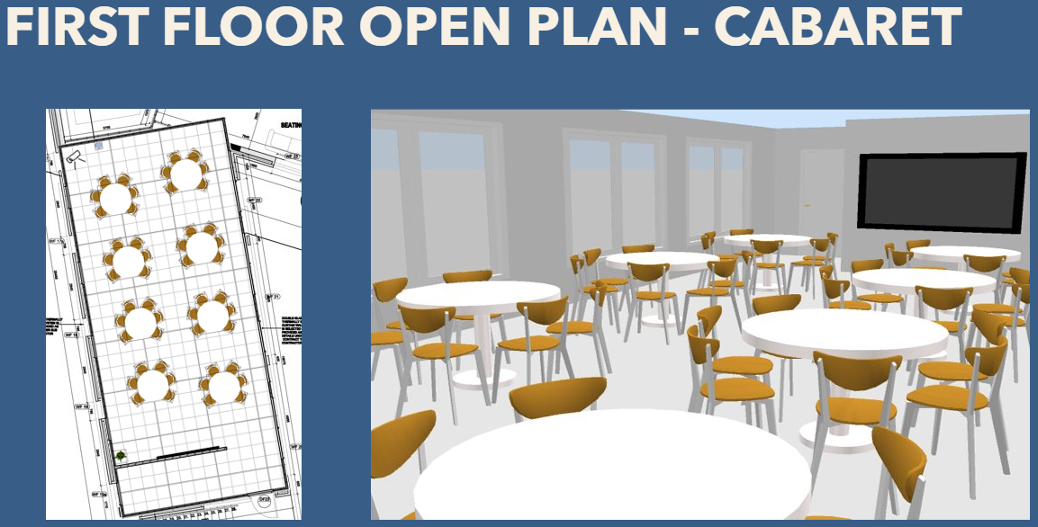

- Kitchenette and adjacent breakout area
Upgrade and refresh of kitchenette incorporating soft seating in the breakout area.

- Toilet Facilities
Upgrade and refresh of accessible, female and male bathroom facilities.

- Accounts Office
This office is currently configured with two desks, and file storage area. Access control required. Updated furniture, flooring, colour scheme.

- IT Office
This office is currently configured for one person. Access control required. Updated furniture, flooring, colour scheme.

- 3 x Offices
To be converted into small meeting rooms with suitable video conferencing technology. GS Office, Dir OSD Office, IT Storage area.

- Former General Secretary PA Office
To be converted into video call room for private calls & meetings.

2.6.3 General

- Extension of the building beyond its original footprint is not envisaged.
- Internal restructuring possible with the removal and reconfiguration of non-load bearing walls.
- Upgrade of all floor coverings and introduction of new fresh contemporary colour scheme and furnishings throughout.

**All illustrations for ideation purposes only**

Section 3 Submission Requirements

3.1 Pricing information to be provided.

In submitting the price, the supplier/service provider must meet the following:
- A detailed quotation outlining the overall cost, broken down by key activities. It must also clearly state the total contract price exclusive of VAT.
- Where the price, or part of the price, is based on fee rates, all rates must be specified, either hourly or daily or both as required.
- In preparing their quote, suppliers/service providers are to consider all risks, contingencies and other circumstances relating to the delivery of the requirements and include adequate provision in the quote and pricing information to manage such risks and contingencies.
- Suppliers/Service Providers are to document in their quote all assumptions and qualifications made about the delivery of the requirements, including in the financial pricing information. Any assumption that the ETB or a third party will incur cost related to the delivery of the requirements must be stated, and the cost estimated, if possible.
- Prices should be tendered in Euro (€) Ex-VAT. Unless otherwise agreed, the ETB will arrange contractual payments in Euro (€).

3.2 Previous Experience
- Portfolio of previous architectural projects of similar scale and complexity to be provided.
- List of key personnel who will be involved in the project, along with their qualifications and relevant experience.
- Any additional services or benefits provided by the firm.

SECTION 4 OUR EVALUATION APPROACH
4.1 Evaluation model
The evaluation model that will be used in this project will be to shortlist only those quotations that meet the pre-conditions and are capable of full delivery on time. These then will be assessed objectively against the stated award criteria.

Each quotation/proposal must meet all these pre-conditions:
Pre-conditions/Minimum Requirements
- The supplier should be duly licensed to operate as an architectural firm in Ireland. Additionally, key personnel involved in the project should hold valid professional certifications and be registered with the relevant architectural bodies.
- The supplier should have appropriate and adequate professional liability insurance coverage. Proof of insurance must be provided upon request.
- The supplier should have the capacity to take on this project within the proposed timeline, considering their current and upcoming project commitments.
- The supplier must demonstrate knowledge of, and compliance with, local building regulations and any other relevant standards.

4.2 Award Criteria
Suppliers will be evaluated using the following criteria.

Evaluation Model for Shortlisting for Interview
Criterion | % Weighting
Cost-effectiveness of the quotation. | 40%
Experience and qualifications of the architectural firm and its personnel | 20%
Previous projects of similar scale and complexity. | 20%
Quality and clarity of the submitted quotation. | 20%

Request for Quotation
Supplier/Service Provider Response
[Category]

Supplier/Service Provider Details
Name: | [Category]
VAT Number | Click here to enter text.
Postal Address: | Click here to enter text.
Contact Person or Persons: | Click here to enter text.
Telephone: | Click here to enter text.
Email: | Click here to enter text.
Internet address (web address) (if applicable) | Click here to enter text.

Confirmations
I submit the following quote in response to your RFQ. I confirm that [Category] is able to deliver the requirements as follows:
- To the required standard | ☐
- By the delivery date | ☐
- In the quantity requested | ☐
- To the/at the location requested | ☐

How We Meet Your Needs
We believe that our quotation proposal meets or exceeds the award criteria, as follows:
Click here to enter text.
In submitting this quotation, we have made the following assumptions:
Click here to enter text.

Pricing
Our total price for delivery of the requirements is €Click here to enter text. exclusive of VAT.
A breakdown of the price is as follows.
Click here to enter text.

Authorisations & Sign Off
I have been authorised to submit this quote on behalf of [Category]
Signature:
Full name: | Click here to enter text.
Title/Position: | Click here to enter text.
Date: | Click here to enter a date.

