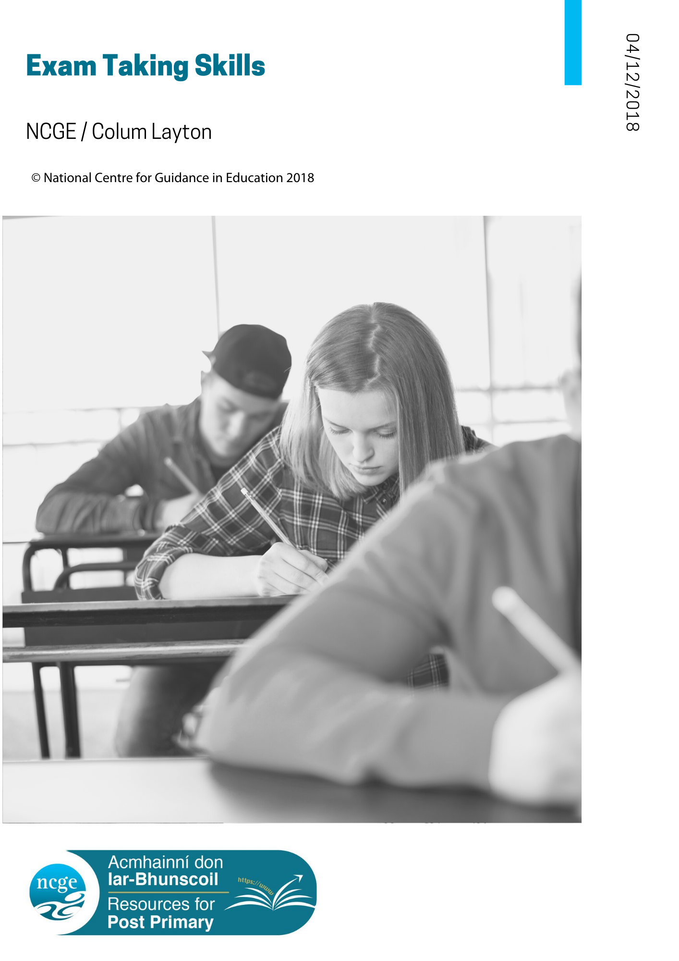
TABLE OF CONTENTS – Exam Taking Skills

The Essentials of Exam Preparation

Exam Taking Skills – Information for Guidance Counsellors
The purpose of this resource is to help guidance counsellors to deal with many of the issues presented by students who wish to improve their approach to examinations. Clearly, while it lists many issues, it provides only a framework on which to explore some of the concerns of students. It does not provide any details or underlying theory about the issues. This information is presented also in sections that may be useful for providing for parents and students, respectively.
These resources on Exam-taking are linked to another resource which summarises effective study skills which you may find useful. This is available from https://www.ncge.ie/resources
Guidance counsellors will be familiar with the many resources in book form, on the internet and in the form of assessment instruments that are available, such as Study - Learning to Learn: A Parents’ Guide by Brian Wall (2013) and published by The Institute of Guidance Counsellors.*
These should be used to underpin normal guidance practice. Similarly, and importantly, academic research and evidence on areas related to examinations, such as stress management, memory, learning and assessment, are in constant development and such evidence should be the basis of informed practice.
It is clearly stated in the student section that, in accordance with the concept of appropriate guidance, the guidance counsellor is there to help those who, having tried to study effectively, wish for affirmation, guidance and help in seeking improvement.
The student section includes several underlying assumptions, such that students will:
- be self-directing and will have made some progress in their studies
- consult important people in their lives when in need of help and encouragement
- have access to a competent guidance counsellor
Some students find it easy to study effectively and to prepare for examinations. They are the fortunate ones. They have found ways of learning more in the limited time available.
Other students, however, find it more difficult. There are many reasons for this. Sometimes the reasons are quite complicated, and students will need the help of guidance counsellors and teachers to seek solutions.
The resource ‘Preparing for Exams’ can be accessed at the end of this document. It can be presented as a quick reference guide to help you, as guidance counsellor, and your students to think about examinations and to encourage them to deal with any of the issues that might arise. In the context of classroom guidance, for example, it is suggested that any of the topics could be used in the context of a series of classroom guidance as part of the area of learning: Developing my Learning (NCGE: A Whole School Guidance Framework, 2017) for lessons on exam preparation. The involvement of subject teachers in the planning and delivery of such content would provide opportunities for whole-school participation in the delivery of the Guidance programme.

The information in the student resource sheet is designed to help students in reviewing their preparation for the exam. They summarise the essentials of exam preparation and fall under the following headings.
- Mind yourself
- Be prepared
- Revise
- The exam

​When to ask for help?
While the student section is intended to help students to devise their own approaches to examinations, some will want to improve their methods or to seek affirmation and encouragement about their current work. The guidance counsellor is suggested as a person to approach if a student, for example,
- Has tried to use some of the ideas listed and they do not seem to work
- Is confused by the number of possible things that can go wrong
- Needs further information about any of the ideas listed
- Needs help in making a start.
- Needs someone to check that what is being done is effective.
Students are encouraged to speak to the guidance counsellor and to subject teachers individually or in class groups. It is suggested that the guidance counsellor would welcome in advance some of the questions that students have in mind, to help in preparing answers to their concerns.
Furthermore, it is suggested that while much information exists about exam preparation, stress management, memory, reading, note taking, etc. in books, such as Study—Learning to Learn: A Parents’ Guide by Brian Wall (2013) and published by the Institute of Guidance Counsellors, and on websites such as https://www.wikihow.com/Prepare-for-an-Exam, https://www.how-to-study.com/ and on the Student Resources section of http://careersnews.ie/ , students should turn to the guidance counsellor for help in resolving any issues they might encounter.*

* Disclaimer: Links to external resources developed by individuals or other organisations are being provided as a convenience and are for informational purposes only. They do not constitute an endorsement or an approval by NCGE, of the content the organisation or individual. NCGE bears no responsibility for the accuracy, legality or content of external resources or for that of subsequent links. It is up to Guidance Counsellors to review whether these resources are appropriate and contact the resource owners directly for answers to questions regarding their content.

Exam taking skills: A Resource for Parents
Clearly, parents and guardians have an important role to play in providing a suitable environment within which students may study and learn. However, with increasing age the responsibility to direct their own studies will fall more and more on students themselves. The role of parents will tend more towards encouraging, facilitating and supporting good study habits and routines, and will be less directive.
The information for students includes several underlying assumptions, such that students will
- be self-directing and will have made some progress in their studies
- consult important people in their lives when in need of help and encouragement
- have access to a competent guidance counsellor
Some students find it easy to study effectively. They are the fortunate ones. They have found ways of learning more in the limited time available. Other students, however, do not reach their full potential when studying. There are many reasons for this. Sometimes the reasons are quite complicated, and students will need the help of parents to seek solutions.
Listed in this resource are suggestions that relate to exam preparation.
The lists are presented as a quick reference guide to help you and your young person to think about examinations and to encourage them to deal with any of the issues that might arise.
It is suggested that, if problems with study still exist after trying and discussing some of the listed items, the student’s guidance counsellor be consulted.

The information in the section ‘Preparing for Exams’ is designed to help students in reviewing their preparation for the exam. They summarise the essentials of exam preparation and fall under the following headings.
- Mind yourself
- Be prepared
- Revise
- The exam

When to ask for help?
Having spoken to your young person about the issues listed above, you might find that they wish to improve their preparation for examinations, or that
- Some of the ideas have been tried and do not seem to work
- They are confused by the number of possible things that can go wrong
- They need further information about any of the ideas
- They need help in making a start
- They need someone to check that what they are doing is effective.
These are the kind of issues that many students face and that guidance counsellors can help to sort out. Students can make an appointment to speak to their guidance counsellor who is there to help those who, having tried to prepare for examinations, wish for encouragement, guidance and help in seeking improvement. Similarly, subject teachers may be approached for more subject-specific suggestions.

What you have read above is a summary of ideas about exams. Guidance counsellors will be familiar with the many resources available not only about exam preparation, but also about topics such as stress management, study, memory, note-taking and healthy living. If you are interested in learning more about anything in this outline, you will find it on websites, such as https://www.wikihow.com/Prepare-for-an-Exam and on the Student Resources section of http://careersnews.ie/. The Institute of Guidance Counsellors has published a more detailed account of exam preparation in the booklet Study - Learning to Learn: A Parents’ Guide by Brian Wall (2013).
Exam taking skills: A Resource for Students
It may be stating the obvious, but examinations occur at the end of a learning process. In the case of State examinations, it is a two- or three-year learning process. In other words, preparation for the examinations begins in First Year.
Study skills established early in post-primary school lay the foundation for effective preparation for the examinations. Some guidelines for effective study may be found at https://www.ncge.ie/resource/effective-study. If you have not established your study habits, you should start now by using the guidelines.
If you are still unsure as to what to do, or if you find an issue that you can’t deal with on your own, try to talk about it with your parents or your guidance counsellor, or with some other important person in your life.
If you have studied well and are preparing for examinations, the following information is designed to help you reviewing your preparation for the exam. They summarise the essentials of exam preparation and fall under the following headings.
- Mind yourself
- Be prepared
- Revise
- The exam
You may find the section at the end of this document, titled ‘Preparing for Exams’ useful.
Further information regarding any of the items on the lists can be found through consultation with your guidance counsellor, your subject teachers or by an internet search.

When to ask for help?
You still might want help in preparing for examinations.
- If you have tried to use some of the suggestions listed and they do not seem to work for you.
- If you are confused by the number of possible things that can go wrong.
- If you need further information about any of the ideas listed above.
- If you need help in making a start.

If you need someone to check that what you are doing is effective. ​These are the kind of issues that many students face, and that guidance counsellors and subject teachers can help you to sort out. You could make an appointment to speak to your guidance counsellor or you could ask your guidance counsellor or subject teachers to speak to your class about exam preparation. Your guidance counsellor would probably welcome some ideas about the kind of questions you, or your classmates, have in mind. This would help in preparing answers to your questions.

What you have read above is a summary of ideas about exam taking. Whole books have been written not only about exam skills and techniques, but also about topics such as study, reading, memory, note-taking and healthy living. If you are interested in learning more about anything in this outline, you will find it on websites, such as https://www.wikihow.com/Prepare-for-an-Exam and on the Student Resources section of http://careersnews.ie/. If any of the topics outlined here are of concern to you or if you find it difficult to put them into practice or, indeed, if you simply wish to be reassured about your study activity, your guidance counsellor is there to help you.

Preparing for Exams: The Essentials of Exam Preparation
Mind yourself
- Keep to your normal routines as much as possible
- Sleep well, and at the usual bedtime
- Eat regularly and have a balanced diet
- Exercise
- Keep to your plan
- Avoid distractions
- If you feel under stress, talk to someone like your parents or guidance counsellor
Be prepared
• Knowing the format of the exam paper can be reassuring
• Be aware that much information exists about the format of exams, especially about the State examinations
• How long is the examination?
• What is the exam format?
• Is the format the same every year?
• Will there be any changes to the format this year?
• Are certain topics associated with each question?
• What types of questions are asked?
• Can some questions be predicted?
• Are past exam papers available?
• Are there short questions and long questions?
• Are there optional questions?
• How many marks are associated with each question?
• How much time should be spent at each question?
• How should you plan your time in the examination?

Revise
- Plan your revision as you would plan your study
- You will find study guidelines at https://www.ncge.ie/resource/effective-study
- Use your notes as much as possible
- When in doubt, use the textbook but avoid the temptation to re-read everything
- Summarise what you know about a topic to help revision
- Ask yourself questions about the topic
- Answer the questions
- Then use your notes or textbook to check your answers
- Try to answer questions under exam conditions, especially by timing your answers
- Take regular breaks, as you would when studying
- Try to achieve a balance between the subjects you like, those at which you are good and those at which you are not so good
- Mind yourself
The exam
• Be rested
• Check your timetable
• Have your pens and instruments ready
• Try to stay calm
• Have a plan of action. How much time will you spend reading the questions? In what order do you intend answering the questions? What options do you have? Will you attempt the easy questions first? Will you jot down notes before you begin? Where will you jot down the notes?
• Read the exam paper carefully. Better to spend a few minutes reading than to misread a question.
• Quickly note the main points of your answers
• Watch your times
• Be sure to answer all questions as required
• Stay until the end of the exam time
• If you have time, read over your answers
• When the exam is over, avoid negative discussions about it and begin your preparations for the next exam

