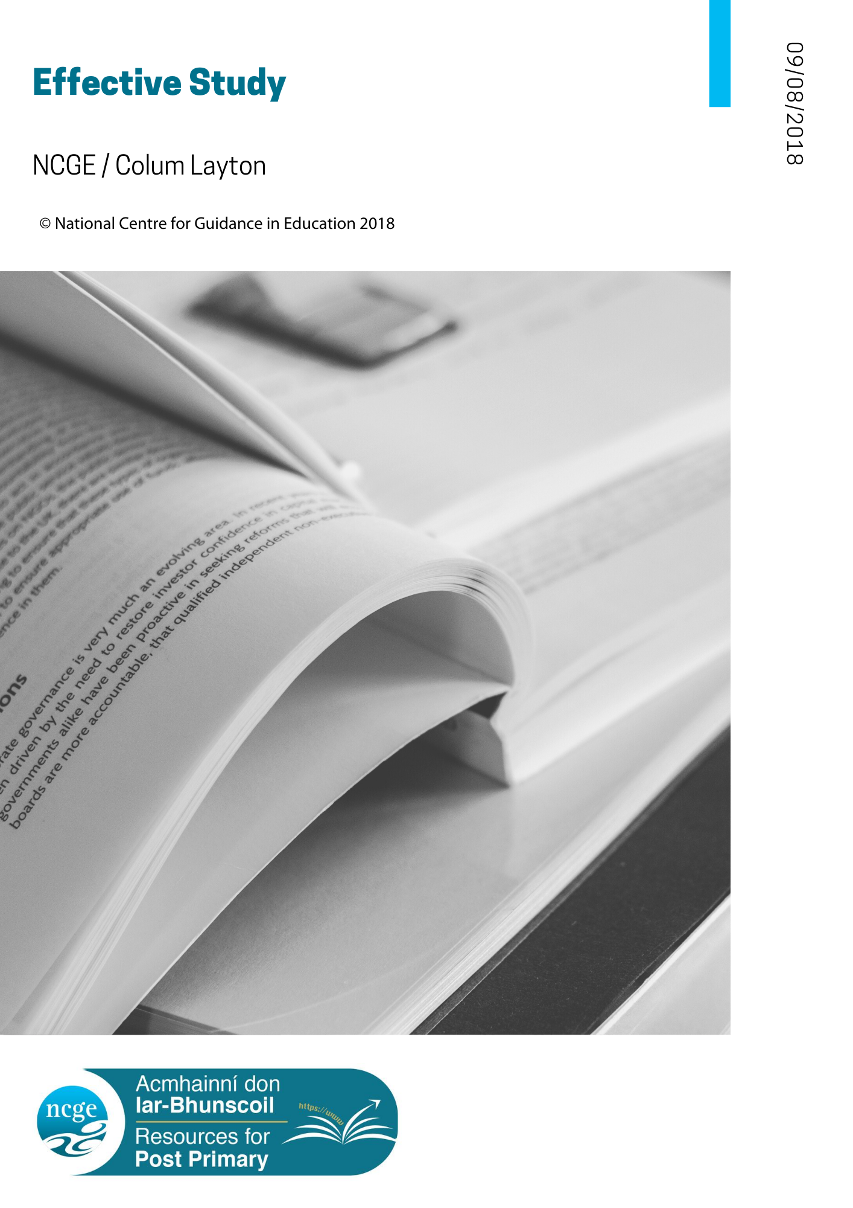

TABLE OF CONTENTS – Effective Study

Effective Study: Information for Guidance Counsellors
What follows is a checklist based on the items in the student information section. Underlying the information for students are several assumptions, namely, that students will:
- be self-directing and will have made some progress in their studies
- aspire to the characteristics of the effective and efficient student
- consult with important people in their lives when in need of help and encouragement
- have access to a competent guidance counsellor
The information for parents’ section is more general in nature but is also based on the content of the information for students.

The purpose of this resource is to help guidance counsellors to deal with many of the issues presented by students who wish to improve their study skills and habits. Clearly, while it lists many issues, it provides only a framework on which to explore some of the concerns of students. It does not provide any details or underlying theory about the issues.

Guidance counsellors will be familiar with the many resources in book form, on the internet and in the form of assessment instruments that are available. These should be used to underpin normal guidance practice. Similarly, and importantly, academic research and evidence on areas related to study, such as memory, learning and assessment, are in constant development and such evidence should be the basis of informed practice.
It is clearly stated in the student section that, in accordance with the concept of appropriate guidance, the guidance counsellor is there to help those who, having tried to study effectively, wish for affirmation, guidance and help in seeking improvement.

Similarly, in the context of the continuum of support promoted by the National Educational Psychological Service (NEPS) and in the context of whole-school guidance, the resource could be used in a variety of settings by the guidance counsellor or by subject teachers, as appropriate. It is envisaged that, for example, it might be used by the guidance counsellor in planning and implementing guidance lessons and in establishing a consistent and coherent approach to study among teaching staff, both in their general approach to study and in advising students about approaches to studying their individual subjects.

In the student section, the issues that can help, or hinder, effective study are grouped under the following categories:

- The effective student
- How you organise your study
- Memory
- Reading
- Note taking

When to ask for help?

While the student section is intended to help students to devise their own study plans and routines, some will want to improve the way they study or to seek affirmation and encouragement about their current work. The guidance counsellor is suggested as a person to approach if a student, for example:

- Has tried to use some of the ideas listed and they do not seem to work
- Is confused by the number of possible things that can go wrong
- Needs further information about any of the ideas listed
- Needs help in making a start.
- Needs someone to check that what is being done is effective.

Issues with study may be subject related for some students. Collaboration by the guidance counsellor with subject teachers in the identification of useful study methods for their subjects might enable teachers to deal with questions from students as they arise. In addition, such collaboration might help teachers to identify students with issues more appropriately dealt with by the guidance counsellor.

Students are encouraged to speak to the guidance counsellor individually or in class groups. It is suggested that the guidance counsellor would welcome in advance some of the questions that students have in mind, to help in preparing answers to their concerns.

It is suggested that while much information exists about study skills, memory, reading, note taking, etc. in books and on websites such as:
https://www.wikihow.com/Study, https://outwittrade.com/study-tips-techniques, https://www.how-to-study.com/ and on the Student Resources section of https://careersnews.ie/. Students should still turn to the guidance counsellor for help in resolving any issues they might encounter.

Further recommended reading:
'Helping students to concentrate while studying' by Aidan Moran could be read in conjunction with this resource.
It can be accessed in the Post Primary Education section of the NCGE Resources webpage
https://www.ncge.ie/resources

Effective Study: Information for Parents
Clearly, parents and guardians have an important role to play in providing a suitable environment within which students may study and learn. However, with increasing age the responsibility to direct their own studies will fall more and more on students themselves. The role of parents will tend more towards encouraging, facilitating and supporting good study habits and routines, and will be less directive.

The student section includes several underlying assumptions, such that students will:

- be self-directing and will have made some progress in their studies
- aspire to what effective and efficient students do in their studies
- consult important people in their lives when in need of help and encouragement
- have access to a competent guidance counsellor

Some students find it easy to study effectively. They are the fortunate ones. They have found ways of learning more in the limited time available.
Other students, however, do not reach their full potential when studying. There are many reasons for this. Sometimes the reasons are quite complicated, and students will need the help of parents to seek solutions.
Listed below are issues that can help, or hinder, effective study. The lists are presented as a quick reference guide to help you and your young person to think about study and to encourage them to deal with any of the issues that might arise.
It is suggested that, if problems with study still exist after trying and discussing some of the listed items, the student’s guidance counsellor be consulted.

For convenience, the issues listed in the student section at are grouped under the following categories:

- The effective student
- How you organise your study
- Memory
- Reading
- Note taking

When to ask for help?

Having spoken to your young person about the issues listed above, you might find that they wish to improve the way they study or:
- Some of the ideas have been tried and do not seem to work
- They are confused by the number of possible things that can go wrong
- They need further information about any of the ideas
- They need help in making a start
- They need someone to check that what they are doing is effective.
These are the kind of issues that many students face, and the guidance counsellor can help to sort out. Having spoken to their subject teacher, students can make an appointment to speak to their guidance counsellor who is there to help those who, having tried to study effectively, wish for encouragement, guidance and help in seeking improvement.

What you have read above is a summary of ideas about study. Guidance counsellors will be familiar with the many resources available not only about study, but also about topics such as reading, memory, note-taking and healthy living. If you are interested in learning more about anything in this outline, you will find it on websites, such as https://www.wikihow.com/Study, https://outwittrade.com/study-tips-techniques, https://www.how-to-study.com/ and on the Student Resources section of http://careersnews.ie/

Effective Study: Information for Students
Some students find it easy to study effectively. They are the fortunate ones. They can learn more in the limited time available. If you are one of them, it is probable that you have dealt with most of the issues listed below. Other students, however, do not reach their full potential when studying. There are many reasons for this. Sometimes the reasons are quite complicated and will need to be discussed with, for example, your guidance counsellor. Listed below are issues that can help, or hinder, effective study. The lists are presented as checklists to help you to think about your studies and to encourage you to deal with any of the issues that might arise. Tick the items as they apply to you. When you have done that, decide on which items you can improve.

When you find an issue that you cannot deal with on your own, try to talk about it with your parents or your guidance counsellor, or with some other important person in your life.

For convenience, the issues to be looked at are grouped under the following categories:

- The effective student
- Organise your study
- Memory
- Reading
- Note taking

When to ask for help?

You still might want to improve the way you study:
- If you have tried to use some of the ideas already listed and they do not seem to work.
- If you are confused by the number of possible things that can go wrong. If you need further information about any of the ideas listed above
- If you need further information about any of the ideas listed above.
- If you need help in making a start.
- If you need someone to check that what you are doing is effective.

These are the kind of issues that many students face, and that guidance counsellors and subject teachers can help you to sort out. Having spoken to your subject teacher, you could make an appointment to speak to your guidance counsellor or you could ask your guidance counsellor to speak to your class about study. Your guidance counsellor would probably welcome some ideas about the kind of questions you, or your classmates, have in mind. This would help in preparing answers to your questions.

What you have read above is a summary of ideas about study. Whole books have been written not only about study, but also about topics such as reading, memory, note-taking and healthy living. If you are interested in learning more about anything in this outline, you will find it on websites, such as https://www.wikihow.com/Study, https://outwittrade.com/study-tips-techniques, https://www.how-to-study.com/ and on the Student Resources section of http://careersnews.ie/. If any of the topics outlined here are of concern to you or if you find it difficult to put them into practice or, indeed, if you simply wish to be reassured about your study activity, your guidance counsellor is there to help you.

The Effective Student
If you study effectively, it is probable that (tick the items as they apply to you) ….
You are reasonably healthy
You sleep well (8-9 hours a night for most people in their teens) ☐
You have regular bedtimes ☐
You eat regularly (Breakfast, lunches/dinner, tea/supper) ☐
You have a balanced diet ☐
You exercise regularly ☐

You have peace of mind
You have people with whom you can talk (Parents, guidance counsellor, teachers, friends) ☐
Your worries have been dealt with ☐
You have leisure activities ☐

You are motivated to study
You have a reason to study ☐
You have clear goals ☐
Your goals are achievable ☐
You have set short term goals ☐
You have chosen interesting subjects ☐
You see why some subjects are necessary ☐
You listen to your teachers
You do your homework ☐
You gather information from radio, TV, internet, school and local libraries, etc. ☐

You have effective study habits

You have a daily routine ☐
You mix different types of subject, like maths and history, science and language ☐
You have time for homework & revision ☐
When planning your study:
You manage your time ☐
You include leisure activities in your plan ☐

RESOURCES
Junior Cycle

How you organise your study
If your study is organised, it is probable that (tick the items as they apply to you) ….
You organise your study
To achieve a balance between study and the other aspects of life ☐
To get things done ☐
To ensure that the important things have been done ☐
To get them done efficiently, without wasting time ☐
To get them done on time ☐
To keep commitments to others ☐
To do the best you can ☐
To remember what needs to be done ☐
To lessen stress ☐
To avoid panic ☐
You have a regular place to study that
Has a seat that is neither too comfortable nor too uncomfortable ☐
Has a firm surface on which to work ☐
Has enough space for books, pens and other materials ☐
Is warm enough, but not too warm ☐
Is bright enough and lacks glare, but is not too bright ☐
Is reasonably quiet ☐
Is free from disturbances ☐
When you plan your study, you ask yourself questions, such as
How do I use my time now? ☐
How should I be using my time? ☐
How can I use my study time more efficiently? ☐

When answering those questions, you bear in mind that
Doing your work as soon as is possible after arriving home helps
to avoid late hours and tiredness ☐
You need to achieve a balance between study and homework ☐
The time spent on study varies from first year to sixth year ☐
The time spent on study varies with the time of year ☐
You need to plan your time so that you can get the work done ☐

You have a long-term plan
Your long-term plan deals with the whole year, or what is left of it ☐
It indicates the amount of time available in which to complete your studies ☐
It might be in the form of a calendar or a timeline, or a chart that is easy to
check and to edit, if necessary ☐

You ask yourself questions
How many days do I have to complete my studies? ☐
How much time should I spend on each subject? ☐
How much time can I spend on each subject? ☐
Do I need to spend more time on some subjects than on others? ☐
Have I included time for revision? ☐

You have a short-term plan
Your short-term plan is probably based on a timetable ☐
Your weekly timetable reflects your school timetable because of homework and
other regular commitments ☐
It includes your leisure activities ☐
Your daily timetable is based on your weekly timetable but is more flexible ☐
This caters for day-to-day events and for changes that you might need to make ☐
Your timetable indicates:
When you should study what to study ☐
How long you propose to spend studying ☐

Your timetable:
Suits your levels of concentration. ☐
Some people can concentrate for longer than others
Suits your preferred ways of learning. ☐
You might prefer to do certain homework before study or vice versa
Is realistic and is not overambitious, you do not try to do too much ☐
Is flexible enough to cater for different events like unexpected visitors and extra
training for games ☐
Balances homework and revision ☐
Includes regular breaks, for variety and to avoid fatigue and boredom ☐
Is arranged in short sessions. ☐
It is suggested that a change of topic or a break should be timetabled after about
40 minutes, or shorter depending on the topic
Takes memory into account ☐

Memory
For our purpose, memory can be divided into:
Short-term memory the memory you use when, for example, you check a phone number, learn something quickly or listen to someone. It is not always easy to recall these when time has elapsed.
Long-term memory the kind of memory that enables you to recall things you have learned, even after some time has elapsed. Ideally, you store things you learn in long-term memory so that they can be recalled later. Some approaches to study help to store what you learn in long-term memory and help you to recall what you have learned.

When you use memory during study, it is probable that (tick the items as they apply to you) ….
You revise ☐
You revise what you have learned soon after learning and regularly afterwards ☐
You are interested in what you study ☐
You understand what you are studying ☐
You understand that what you are studying is part of a bigger subject ☐
You use questions about what you are learning and then studying to find the answers ☐
You make connections between what you are studying and things that you have
already learned ☐
You use a variety of approaches to what you are studying ☐
For example, reading, writing, creating diagrams, note taking, reciting, even singing.
The more senses you use, the better
You separate similar material. For example, separating the study of
two languages with some science or maths ☐
You complete the topics that you find more difficult while you are still fresh ☐
You see and creating patterns and similarities in what you study ☐
You break the material into shorter chunks ☐
This tends to be more effective than trying to learn a lot in one go
Before finishing a topic, you test your recall ☐
Checking to see if you remember what you have studied

Reading
When reading effectively, it is probable that (tick the items as they apply to you) ….
You find being actively involved is more effective than just reading the text ☐
You use different approaches for different types of text, for example,
reading a story and reading mathematics ☐
You balance speed with comprehension. You understand a text does not
always require every word on a page to be read ☐
You use summaries, diagrams, headings, pictures, etc. to scan the text quickly ☐
You ask yourself some questions or write some questions about what you
have seen in the text ☐
You then read the text to answer the questions ☐
You briefly summarise your answer in a note or a diagram ☐
You check that your answers are correct ☐
After reading you take notes that can be used later for revision ☐

Taking notes
When you are taking notes for study, it is probable that (tick the items as they apply to you) ….

You make notes that summarise what you have read, what you have learned
and what you have done ☐
You highlight, underline and write key words helps to identify important ideas
in the text ☐
You use visual notes such as diagrams, maps, pictures which help you
to remember ☐
You put your notes on cards can be useful when revising the material ☐

