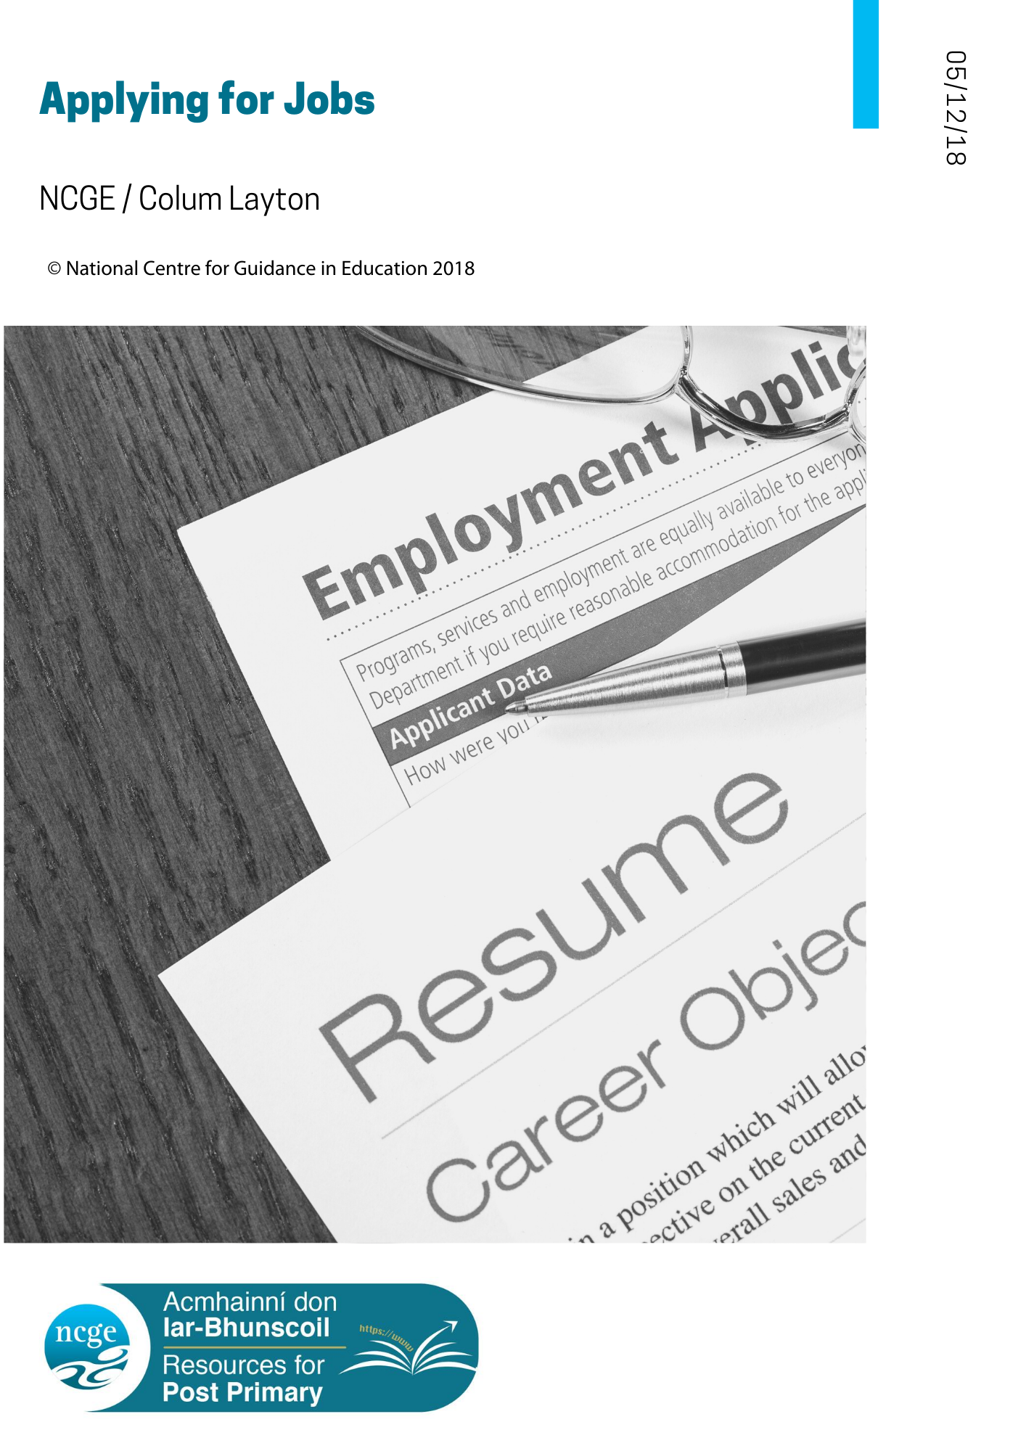

TABLE OF CONTENTS – Applying for Jobs

- Applying for Jobs – Information for Guidance Counsellors
The following resource for students has been prepared for those who wish to apply for a job. You may wish to print this section of the resource separately to provide for your students.
This section suggests that students applying for jobs as part of work experience/placement/shadowing/seasonal part-time work will probably go through the following stages.
They will:
- Have identified what work they prefer (from experience, learning, courses etc)
- Seek information about jobs, such as how to apply
- Have identified a job that is of interest
- Prepare a CV and, if necessary, an application form
- Submit a covering letter, to introduce themselves
- Await a reply
Clearly, your role as guidance counsellor in the longer term is to encourage students to reflect on their interests and experiences, to help them to clarify their personal preferences, to access information about work, careers and the labour market and to help them to decide what areas of work are most likely to match their preferences. You may find the ‘Understanding Your Interests’ section of this resource useful. This section can be provided to students to support student learning regarding their interests and aptitudes. ‘Understanding Your Interests’ can be applied in a classroom setting by presenting to students for completion, followed by discussion of their choices in small groups.
This Applying for Jobs resource provides links to the Europass website, which is highly recommended as an asset in guidance provision. In particular, the Europass website facilitates job applications through an easy-to-use interface bringing jobseekers through the development of a CV and cover letter, among others.

In addition to your longer-term work in supporting students career development, it is suggested that the preparation of a CV and cover letter might be the subject of a number of classroom guidance sessions as part of the area of learning: Developing My Career Path (Guidance for All) (NCGE: A Whole School Guidance Framework, 2017) and in individual work with students, based on the Europass website at: https://europass.eu and on the QQI website at: https://www.qqi.ie/Articles/Pages/Qualifications-and-Skills.aspx
More specifically, CV preparation will be found at:
https://europa.eu/europass/en/create-europass-cv
and the preparation of a cover letter at:
https://europa.eu/europass/en/create-europass-cover-letter
It is further suggested that, as communication skills, students might be exposed to learning these skills through collaborative work among teachers in a variety of programmes and subjects, and by the creative use of information technology in job searches, information seeking and the preparation of documents.

- Applying for Jobs - Information for Students
Whether you are looking for a part-time or a full-time job, whether the job is in Ireland or abroad, the process of applying is similar.
You will probably go through the following stages. You will.
- Have identified what you prefer (from experience, subjects, pastimes and interests etc.)
- Seek information about jobs, such as how to apply
- Identify a job that is of interest
- Prepare a CV and, if necessary, an application form
- Submit a covering letter, to introduce yourself
- Await a reply
Identify your preferences (experience, subjects, pastimes etc)
Your success in finding a satisfying job depends a lot on two types of information.
- About yourself
- About the job
Clearly, that information is important, but it takes time to work out. It involves knowing the kind of person you are and what you consider to be important. For example, do you like being with people? are you active and athletic? are you musical or artistic? how important are material things to you? and will these influence the type of work you are willing to do? Your guidance counsellor may provide you with additional resources that may assist you in identifying your strengths and interests.
Similarly, finding out about a job involves gathering information and experience that will help you to find a job that you like. For some jobs, especially temporary or part-time work, the pay might be the attraction. For longer term work, your previous experience and qualifications will influence your choices, as will your preferences for, for example, work indoors or outdoors, work with people, technical work etc.
If you have not already done so, you could talk to your guidance counsellor and other important people in your life to answer some of those questions.

You will seek information about jobs, such as how to apply
Some jobs require previous experience or training before you apply for them. Applying for such jobs can involve some formality. For these, you might be required to submit documents, such as certificates, application forms and personal statements. A job advert will usually include details about the work, the application process and the type of person required. Your guidance counsellor can help you to find this information.

You will have identified a job that is of interest
Finding a job can be as simple as asking an employer, or a relative, for work or responding to an ad in a shop window. On the other hand, you might decide to contact as many employers as possible either by letter or by email.
The Europass website https://europass.eu has been developed to help jobseekers in their search for work.

You will prepare a CV and, if necessary, an application form
The CV, or curriculum vitae, is a summary of your life. It should outline your education and other experience as a continuous process up to the present. In general, it contains personal information such as.
- your name and contact details
- your educational experience
- your experience of work, including voluntary work
- the names of people who will vouch for you, called referees

https://europa.eu/europass/en/create-europass-cv provides a very useful guide and template to help you to prepare a CV and covering letter.

You will submit a cover letter, to introduce yourself
A cover letter to introduce yourself will form part of the documents. The cover letter you need to include with your application is a one-page summary of your application and usually contains details of:
- what you are applying for
- who you are
- why you are interested in the job
- what you can bring to the job
- a request for an interview
The Europass website at https://europa.eu/europass/en/create-europass-cover-letter will help you to prepare a high quality covering letter.

You will await a reply
Once you have submitted your application you may receive a reply from the employer and a call to interview. If some time has elapsed after the closing date for applications, a polite request for information about the application process can be made. You should note that the timeline for a reply by the employer is sometimes given in the job description and that this should be consulted before making enquiries.
Understanding Your Interests
Adapted with kind permission from the Career Guidance Center, City of Gothenburg, Sweden.

Understanding Your Interests:
Is the first step towards building
a successful career.

Interests:  • Catch your attention  • Awaken your  curiosity  • Are enjoyable  • Are satisfying  • Can change easily | Aptitudes:  • Are easy for you  • You are naturally  good at  • You stand out at  • Are your talents

Time to Think: Read carefully and respond to the exercise when ready.
Look at the box on the next page. You will see a list of subjects and activities. Think about your interests and your aptitudes (talents). Then mark the red box for your interests and tick the blue box for your aptitudes. If you have interests and talents that are not on this list, you can add them (under ‘other’) at the bottom of the box.

 | Int. | Apt. |  | Int. | Apt.
History | ☐ | ☐ | Art | ☐ | ☐
Science | ☐ | ☐ | Woodwork | ☐ | ☐
Teaching others | ☐ | ☐ | Singing | ☐ | ☐
CSPE | ☐ | ☐ | Sport | ☐ | ☐
Games | ☐ | ☐ | Geography | ☐ | ☐
Cooking/Baking | ☐ | ☐ | Craft | ☐ | ☐
Personal Styling | ☐ | ☐ | Caring for others | ☐ | ☐
Business | ☐ | ☐ | Decorating | ☐ | ☐
Maths | ☐ | ☐ | Music | ☐ | ☐
Writing | ☐ | ☐ | Irish | ☐ | ☐
Reading | ☐ | ☐ | Nature | ☐ | ☐
Computers | ☐ | ☐ | Design | ☐ | ☐
Languages | ☐ | ☐ | Metalwork | ☐ | ☐
Acting | ☐ | ☐ | Engineering | ☐ | ☐
English | ☐ | ☐ | Photography | ☐ | ☐
Technical Graphics | ☐ | ☐ | Technology | ☐ | ☐
Religion | ☐ | ☐ | Problem-solving | ☐ | ☐
Animals | ☐ | ☐ | Classical studies | ☐ | ☐
Other | ☐ | ☐ | Other | ☐ | ☐
Other | ☐ | ☐ | Other | ☐ | ☐

Now write down the areas where you have ticked both the red box (interest) and the blue box (aptitude):
Click or tap here to enter text.

