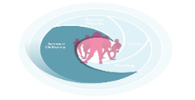
DCYA UID Code:
Planning Period : To: From:

Output Plan (for each programme that will be delivered please complete one line of the template below)
Group/Engagements with young people  (including age range) | Target Group as per SR | Method used (i.e. small group coaching, drop in, youth forums, one to one mentoring etc.) | Time and day delivered | Number of sessions to be delivered in next reporting period | Number of individual young people to be targeted | Staff allocated | Estimated number of contacts
Plan for other relevant areas of work

Please To calculate this figure multiply the number of individual young people expected to attend sessions by the number of sessions planned i.e. if 3 young people attend 4 sessions then it results in 12 contacts add one to ones, outreach and events as contacts. Any unplanned contacts with young people may be added once you have noted them in some way.

