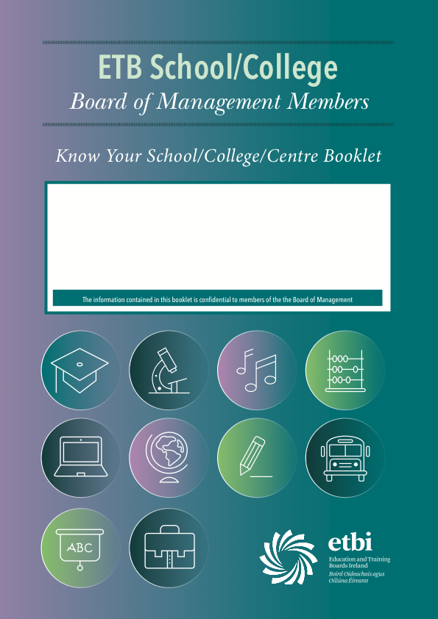

School/College/Centre:
Roll No:
Principal:
Deputy Principal:
Date of most recent revision:
Table of Contents

Topic | Page No
Role and Function of ETB
Role and Function of ‘Trustee Partner’
Mission Statement
Brief History of School / College / Centre
Location, Catchment Area, Feeder Schools, Neighbouring Second-Level Schools
Board of Management 2014 – 2019
School / College / Centre Management Structure and Decision-Making Processes
School / College / Centre Personnel
Posts of Responsibility
Summary of Teaching Staff
Subject Teachers
School Policies
School Calendar
Admission Criteria
Student Transfers from other Second-Level Schools
School’s Pastoral Care Structures / Supports
Details of Special Needs Provision
Parents’ Association – Structure, Officers, etc.
Student Council – Structure, Membership, etc.
Student Profile
School Enrolment – Last 10 years
School Self-Evaluation Reports
School Improvement Plan / DEIS Action Plan
School Plan – with date for next review
Recent School Inspection Reports
Student Academic Achievements

Curriculum

List of Current PLC Courses offered & delivered
Evening Class Programme
Extra-Curricular Activities – Student Involvement / Achievement

School Accommodation / Facilities

Urgent Teaching and Learning Accommodation Needs

Medium-term Teaching and Learning Accommodation Needs

Finance

Financial Challenges facing the School

Four Key Strengths of the School

Four Opportunities for the School

Four Non-Financial Challenges Facing the School

Four Threats to the Future of the School

Role and Function of ETB

Role and Function of ‘Trustee Partner’
(In case of a designated community College)

Mission Statement

Brief History of School / College / Centre
150 words approximately

Location, Catchment Area, Feeder Schools, Neighbouring Second-Level Schools – Map included at Appendix 1

Board of Management 2014 – 2019

ETB Nominees:

Trustee Partner Nominees:

Teacher Nominees:

Parent (or Student) Nominees:

Business Representatives:

Community Representatives:

School / College / Centre Management Structure and Decision-Making Processes

School / College / Centre Personnel
Teaching and Non-Teaching

Principal:
Deputy Principal:
Director of Adult Education:
Chaplain:
1st Year Head:
2nd Year Head:
3rd Year Head:
4th Year Head:
5th Year Head:
6th Year Head:
Guidance Counsellor:
Programme Co-ordinator:
LCA/LCVP Co-ordinator:
VTOS Co-ordinator:
FETAC Co-ordinator:
BTEI Co-ordinator:
Examinations Co-ordinator:
Health and Safety Co-ordinator
Staff Safety Representative
Administration Staff:
Porter / Caretakers:
Canteen Staff:
Cleaning Staff:
[Add/delete as appropriate]

Posts of Responsibility
Assistant Principals | Post Title / Duties

Special Duties Teachers | Post Title / Duties

Adult Education | Post Title / Duties

Summary of Teaching Staff
Number of Teachers on Staff: Total: Male: Female:
Number of Permanent Whole-time Teachers (including CIDs):
Number of Permanent Part-time Teachers:
Number of Fixed Term Whole-time Teachers:
Number of Fixed Term Part-time Teachers:
Number of Secretary (s): Cleaner (s): Caretaker (s):
Subject Teachers

Teacher Name | Subject

School Policies

Policy Title | Date adopted by Board | Date of Next Review
Admissions & Participation Policy incorporating procedures for transferring from another second- level school – see full policy at Appendix 2
Child Protection Policy – see Appendix 3
Anti-bullying Policy – see full policy at Appendix 4
School Code of Behaviour and Disciplinary Policy – see full policy at Appendix 5
List all other policies

School Calendar – See Appendix 6

Admission Criteria
(Extract from Admissions Policy)

Student Transfers from other Second-Level Schools
(Extract from Admissions Policy)

School’s Pastoral Care Structures/Supports

Details of Special Needs Provision

School Organisations

Parents’ Association – Structure, Officers, etc.

Student Council – Structure, Membership, etc.

Other

Student Profile

Year Group | Total | Boys | Girls
1st Year
2nd Year
3rd Year
Transition Year
5th Year – Leaving Certificate
5th Year – Leaving Certificate Applied
6th Year – Leaving Certificate
6th Year – Leaving Certificate Applied
Post Leaving Certificate – Year 1
Post Leaving Certificate – Year 2
Post Leaving Certificate – Year 3
Total

School Enrolment – Last 10 Years
Year | Enrolment
1998/1999
1999/2000
2000/2001
2001/2002
2002/2003
2003/2004
2004/2005
2005/2006
2006/2007
2007/2008
2008/2009
2009/2010
2010/2011
2011/2012
2012/2013
2013/2014
2014/2015

School Self-Evaluation Reports – Appendix 7

School Improvement Plan / DEIS Action Plan – Appendix 8

School Plan – with date for next review – Appendix 9

Recent (2 years) school inspection reports – Appendix 10

Student Academic Achievements
(Percentage transferring to 3rd Level, recent performance in Junior Certificate and Leaving Certificate examinations – comparison with national averages)

Curriculum
Subjects offered at Senior Cycle
SUBJECT | SUBJECT | SUBJECT

Subjects School would like to offer at Senior Cycle
SUBJECT | SUBJECT | SUBJECT

Subjects offered at Junior Cycle
SUBJECT | SUBJECT | SUBJECT

Subjects School would like to offer at Junior Cycle
SUBJECT | SUBJECT | SUBJECT

List of Current PLC courses offered & delivered - see Appendix 11

Evening Class Programme – Appendix 12

Extra-Curricular Activities – Student Involvement / Achievement

School Accommodation / Facilities

% of accommodation Permanent
% of accommodation Prefabricated
Average Age of Prefabricated Buildings
No of General Classrooms
No of Science Laboratories
No of Home Economics rooms
No of Art rooms
No of Metal Work rooms
No of Engineering rooms
No of Woodwork rooms
No of Building Construction rooms
No of Technical Graphics rooms
No of Design & Communications Graphics rooms
List other specialist rooms
List of sports facilities

Urgent teaching and learning accommodation needs

Medium-term teaching and learning accommodation needs

Finance
Budget allocation for current school year:

Budget for current school year – see Appendix 12
Main items of expenditure:

Are there other school accounts in existence?
Balance in each bank account
Account Name | Balance

Any financial challenges facing the school

Four Key Strengths of the School
1.
2.
3.
4.

Four Opportunities for the School
1.
2.
3.
4.

Four Non-Financial Challenges Facing the School
1.
2.
3.
4.

Four Threats to the Future of the School
1.
2.
3.
4.

