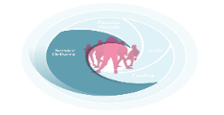
Work report - for each programme delivered or engagement(s) with a young person please complete one line of the template below
(Collate total numbers of one to one engagements, both planned and unplanned, and input using one line only)
DCYA UID Code:
Reporting period: To: From:

Group / Engagements with young people (including age range) | Target Group as per SR |  | Method used (i.e. small group coaching, drop in, youth forums, one to one mentoring etc.) | Time and day delivered | Number of sessions delivered in this reporting period | Number of individual young people that attended | Staff allocated | Total number of contacts | Evidence of Progress
Challenges and opportunities (where relevant)

Discussion and decisions arising from challenges and opportunities.
Other relevant areas of work

To calculate this figure multiply the number of individual young people attending sessions by the number of sessions delivered i.e. if 3 young people attend 4 sessions then it results in 12 contacts Please add one to ones, outreach and events as contacts. Any unplanned contacts with young people may be added once you have noted them in some way.

